<Game Title>
  - CIST2740-201601-21362: TECHNICAL Design Document
[Slogan, Genre, or Brief High Concept]
GTC Game Studios
Tel 770-962-7580  Web http://www.gwinnetttech.edu | 5150 Sugarloaf Pkwy, Lawrenceville, GA 30043  Copyright © 2016 All rights reserved, Clinton A. Lowe, Gwinnett Technical College, and CIST2740 Alumni | [Version]

Contents
Revision History 1
History 1
1. Objectives 2
2. Coding Standards 3
3. Tools 4
4. Game Engine 5
5. Risks and Contingencies 6
6. Security 7
7. Revision Control 8
8. Artificial Intelligence 9
9. Physics 10
10. Input/Output (I/O) 11
11. Hardware Considerations 12
12. Multiplayer and Internet 13
13. Graphics 14
14. Sound 15
15. Localization 16
16. Research and Development (R&D) 17

Revision History

History
The following revisions have been made to the document since its first release in version 1.0.0. The version and section indicated in the table below identifies the revision and location of the affected change. Changes entered into this table shall be listed in descending order by version such that new revisions appear first. And, effected sections shall be listed in ascending order within each applicable version.

Ver. | Section | Description of Change
1.0.0 |  | File Has been updated. 5/5/2026

Objectives

What are the software components of the game? Outline the program flow and relationships between data here. That includes all important algorithms and their sources, as well as any external technical documents that can provide more information. Tables and flowcharts are very helpful in this section.
The game is built in Unity 6000.0.44f1 and uses mostly C# scripts with some ShaderLab content. The main software components include player control, camera control, UI, physics, sound, enemy AI, level objects, and scene management.\
The program flow:
Steps | System | Comment
1 | Main Menu | Player starts the game or exits.
2 | Scene Load | Unity loads the level.
3 | Player Spawn | Character spawn, camera spawns, and enemies are initialized.
4 | Gameplay Loop | Player input, AI, physics and audio update per frame.
5 | Win/Lose | Game checks the player’s win or lose condition(s).
6 | End Screen | Player ends game and can restart or exit.

Coding Standards
The team follows the basic rules for C# coding.
Rules:
-PascalCase
-camelCase
-public/private variables
-proper uses of constants

Tools
The team is using several first party and third-party tools during development.

Tool Purpose
Unity Main game engine and editor
GitHub Version control and team file sharing
Discord Team communication and scheduling
Microsoft Word Writing design documents and reports
Google Chrome Research and documentation
Blender Asset creation
Visual Studio C# script editing, supported by the project packages

Game Engine
The game is powered by the Unity Engine, using the free Unity license. Unity is a third-party game engine.

System Technology
Rendering Unity renderer
Physics Unity Physics
AI Unity AI / AI Navigation
Sound Unity Audio
UI Unity UI / UIElements
Camera Cinemachine

Risks and Contingencies
The team is using Github and local saves to hold the game files. Each developer on the team has hard download of the game and uploads each change to the Github repository. The schedule is managed through communication in the discord channels.

Security
The repository is only available to be accessed through our protected link. The security is less of an issue as our “studio” isn’t profiting from our game.
Currently the team abides by:
-Do not share repository access publicly.
-Do not upload passwords, personal information, or private keys.
-Only trusted team members should make changes.
-Back up important files.
-Use GitHub access control when possible.

Revision Control
Using the Github repository we’re able to use old saves as needed, but no one uploads a broken build. A broken upload could jeopardize future developments for the game as learned throughout this course.
Team rules:
-Do not upload broken builds.
-Test changes before committing.
-Use clear commit messages.
-Pull the latest version before working.
-Keep backup copies locally.
-Return to older commits if a new version causes problems.

Artificial Intelligence
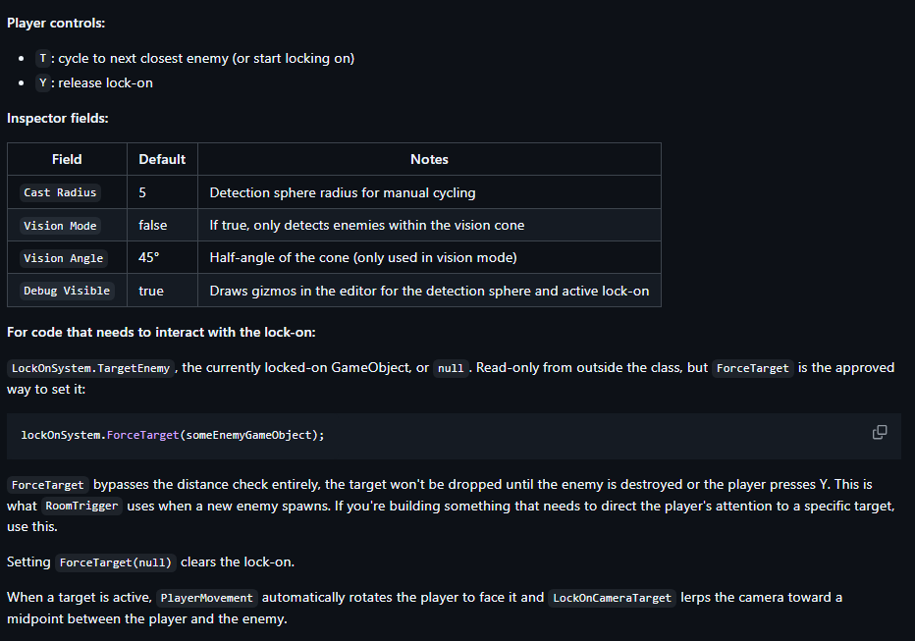
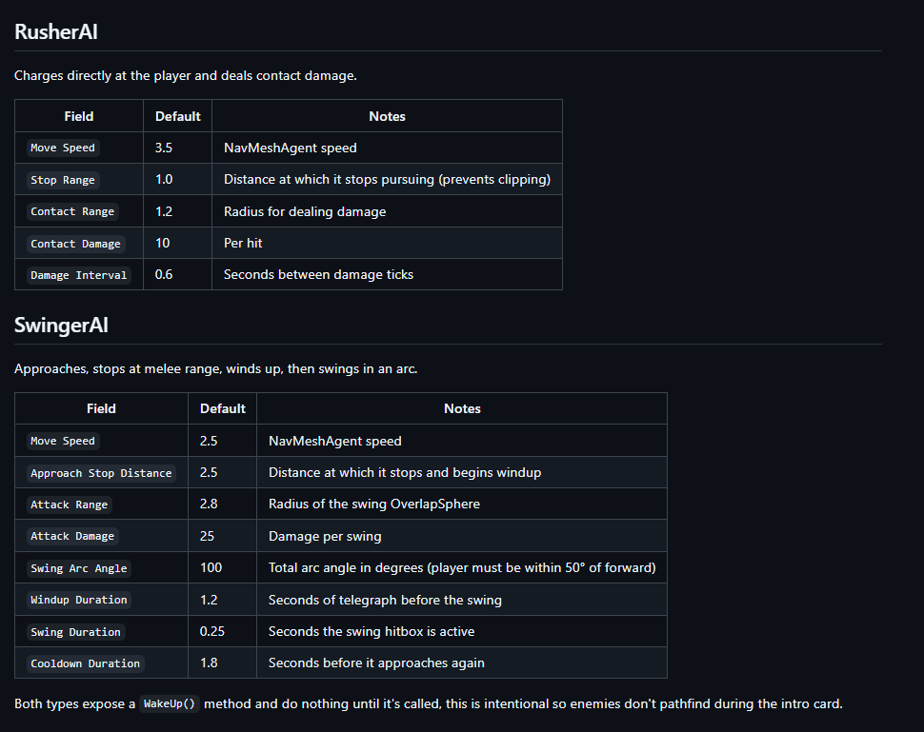

Physics
The game world is simulated using Unity Physics. The project includes Unity physics modules for 3D and 2D physics.
-Player movement and collisions
-Enemy collisions
-Gravity
-Projectiles
-Triggers
-Interactable objects
-Environmental hazards

Rigid bodies and colliders are used as needed.

Input/Output (I/O)
The game features no data streaming as the entire game must be downloaded to play. The game is formatted as an .exe so users won't be able to access the source code.
The main input system include:
-Keyboard for movement and actions
-Mouse for camera control, aiming, and UI selection
-Optional controller support if time allows

Hardware Considerations
Minimum PC Specifications

Operating System: Windows 10 64-bit
CPU: Intel Core i3 or AMD Ryzen 3
RAM: 8 GB
GPU: NVIDIA GTX 750 Ti / AMD Radeon RX 560 / integrated graphics with DirectX 11 support
Storage: 5 GB available space
DirectX: Version 11
Input: Keyboard and mouse

Recommended PC Specifications

Operating System: Windows 10/11 64-bit
CPU: Intel Core i5 or AMD Ryzen 5
RAM: 16 GB
GPU: NVIDIA GTX 1650 / AMD RX 580 or better
Storage: 5–10 GB available space, SSD recommended
DirectX: Version 12
Input: Keyboard and mouse

The Game will not be taking advantage of special technologies and will be split amongst the base level of required cores. The game will run at a minimum of 30fps.

Multiplayer and Internet
-The game does not feature multiplayer content-

Graphics
The game is being developed in Unity 6000.0.44f1, using C# scripts. The project utilizes Unity packages for UI, particles, physics, terrain, 2D tools, Cinemachine, and AI Navigation, so the game’s visuals will be handled through Unity’s normal rendering and scene pipeline.
Unity renders the scene to the game camera:
-Game objects, terrain, characters, props, and enemies are placed in Unity scenes.
-Materials, textures, lighting, and shaders define how the objects look.
-The camera renders visible objects in each frame.
-Unity applies lighting, shadows, effects, particles, and UI elements.
-The final image is displayed to the player.

The UI features:

-Main Menu
-Pause menu
-Health Status
-Objective text
-Interaction prompts
-settings

The main art was done using:
-Unity editor
-Microsoft paint
-Blender

Sound
Storage and Memory Requirements

Audio files have been kept small enough that the game can run on low-end systems.

Estimated audio storage:

Sound effects: 50–200 Mb
Music: 100–500 Mb
Total target audio size: under 1 GB

Encoding and File Formats

Recommended formats:

WAV for short, high-quality sound effects during development
OGG Vorbis or compressed Unity audio for music and final builds
MP3 can be used for music, but OGG is usually better for looping game audio

Audio Retrieval and Playback

Unity’s audio system handles playback. Sound effects will play when actions occur, such as footsteps, attacks, enemy reactions, or menu selections. Background music will play through a separate audio source and may loop during gameplay.

Audio Sample Rates

Recommended sample rates:

44.1 kHz for standard game audio
48 kHz if higher quality is needed

Quality and Noise Reduction

Background noise, clipping, and volume imbalance have been reduced using audio editing tools such as Audacity.

Localization
The first target territory for the game will be to English-speaking PC audiences.

NTSC and PAL Differences

The game should support common PC resolutions such as 1280×720, 1920×1080, and higher.

Language and Text Differences

If the game is translated later, text may become longer or shorter depending on the language. UI boxes should leave extra space, so translated words do not overlap or get cut off.

Character Counts and Safe Zones

Menus, UI, and other texts all function within the PC resolutions.

Legal and Technical Terms

The game isn’t being fully released to audiences, so legalities aren’t a concern.

Text Embedded in Images

Text has been rendered in Unity UI so it can be edited or translated later.

Research and Development (R&D)
Areas Requiring R&D

The team should research and test:

-Enemy navigation using Unity AI Navigation/NavMesh
-Camera movement and behavior using Cinemachine
-Player controls and responsiveness
-Performance on lower-end PCs
-UI readability at different resolutions
-Particle effects and lighting performance
-Audio balancing and looping music
-Scene loading and memory usage

Required Materials

R&D may require:

-Unity Editor
-Test scenes
-Placeholder models and textures
-Sample audio files
-Performance testing on multiple PCs
-Version control through GitHub

